Exp 8 output

% Program:

original_image = imread('Flower.png');

gray_image = rgb2gray(original_image);

% Apply edge detection filters

sobel_filtered = edge(gray_image, 'Sobel');

prewitt_filtered = edge(gray_image, 'Prewitt');

roberts_filtered = edge(gray_image, 'Roberts');

% Display results in subplots

figure;

subplot(2,3,1), imshow(original_image), title('Original Image');

subplot(2,3,2), imshow(gray_image), title('Grayscale Image');

subplot(2,3,3), imshow(sobel_filtered), title('Sobel Filter');

subplot(2,3,4), imshow(prewitt_filtered), title('Prewitt Filter');

subplot(2,3,5), imshow(roberts_filtered), title('Roberts Filter');

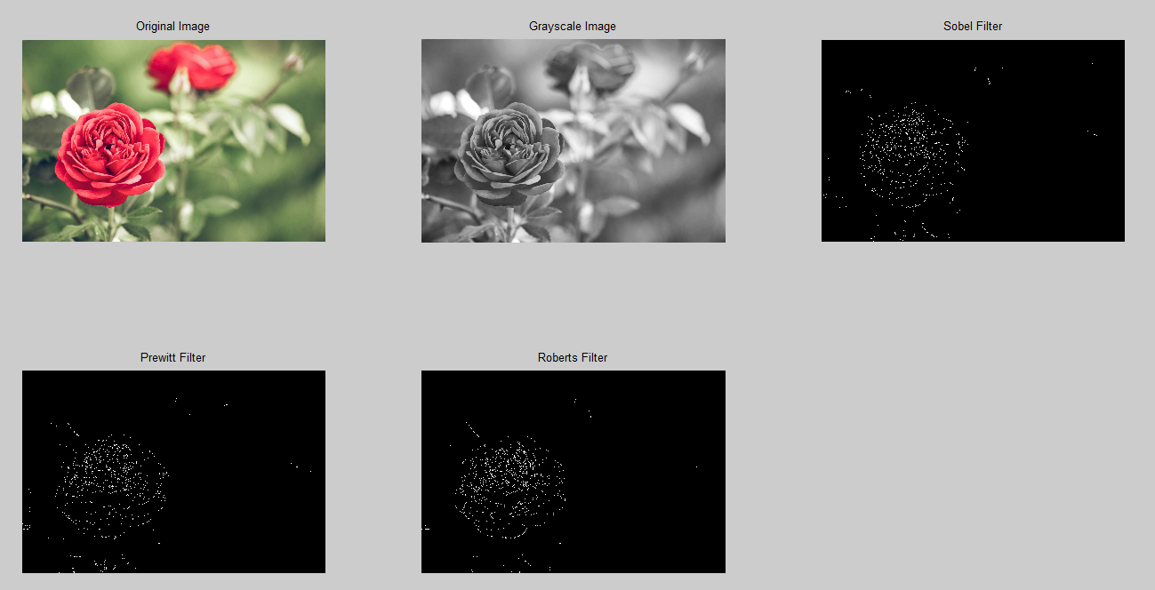

Expt 9

clc;

close all;

clear all;

% Read the image

x = imread('Flower.png');

% Convert to grayscale if needed

if size(x, 3) == 3

x = rgb2gray(x);

end

% Display the original image

figure, imshow(x);

title('Original Image');

% Perform Discrete Cosine Transform (DCT) on the image

F = dct2(double(x));

% Display the transformed Image

figure, imshow(log(abs(F)), []);

title('Transformed Image (DCT)');

% Perform inverse Discrete Cosine Transform (IDCT)

ff = idct2(F);

% Display the reconstructed image

figure, imshow(uint8(ff));

title('Reconstructed Image');

% Initialize matrices

[r, c] = size(x);

DF = zeros(r, c);

DFF = zeros(r, c);

IDF = zeros(r, c);

IDFF = zeros(r, c);

depth = 4; % Depth for DCT coefficients

N = 8; % Block size

for i = 1:N:r-N+1

for j = 1:N:c-N+1

% Extract block from the image

f = double(x(i:i+N-1, j:j+N-1));

% Perform DCT on the block

df = dct2(f);

DF(i:i+N-1, j:j+N-1) = df;

% Perform IDCT on the DCT coefficients

dff = idct2(df);

DFF(i:i+N-1, j:j+N-1) = dff;

% Consider depth for DCT coefficients

df(depth+1:N, :) = 0;

df(:, depth+1:N) = 0;

IDF(i:i+N-1, j:j+N-1) = df;

% Perform IDCT on the DCT coefficients with depth considered

idff = idct2(df);

IDFF(i:i+N-1, j:j+N-1) = idff;

end

end

% Display the DCT coefficients and reconstructed images

figure, imshow(DF / max(DF(:)));

title('DCT Coefficients');

figure, imshow(DFF / max(DFF(:)));

title('Reconstructed Image');

figure, imshow(IDF / max(IDF(:)));

title('DCT Coefficients with Depth Considered');

figure, imshow(IDFF / max(IDFF(:)));

title('Reconstructed Image with Depth Considered');

